SIIRTUNIVERSITY

**2019-2020 ACADEMIC YEAR**

**VACANCY QUOTA OF INTERNATIONAL STUDENTSANDAPPLICATION REQUIREMENTS**

**Vacancy Quota Application Dates :** 6 September2019- 13 September 2019

**Exact Registration Date of Vacancy Quota :** 16 September 2019­18October 2019

**APPLICATION PLACE:**Applications will be received on [https://obs.siirt.edu.tr/oibs/ogrsis/basvuru_yabanci_login.aspx](https://obs.siirt.edu.tr/oibs/ogrsis/basvuru_yabanci_login.aspx%20). Applications will be able to be done only online.

1. GENERAL REQUIREMENTS Applicants:
2. **On condition that they are senior students or graduated;**
   1. The ones who are foreign national,
   2. The ones born as a Turkish citizen who take declaration of Turkish alienage from Ministry of Interior and their children under 18 years old who has documents that show whether s/he has rights to use Turkish citizen rights according to Turkish Citizenship Law . (It is recommended to read Turkish Citizenship Law before application)
   3. The ones with dual nationality who take Turkish citizenship with acquired nationality when they are foreign national,

**4)**The ones as Turkish citizens who have completed all of their secondary education in a foreign country except from Turkish Republic of Northern Cyprus (Including the ones who have completed all of their secondary education in a Turkish school in a foreign country except from TRNC)

**5)**The ones who are TRNC citizens, dwell in TRNC, have completed their secondary education in TRNC, have the exam results of GCE AL and have or will have the exam results of GCE AL by taking education after registration from colleges and high schools in other countries between the dates of 2005-2010

**Applications will be accepted.**

1. Applicants;

**1)**The ones with Turkish nationality who have completed their secondary education in Turkey or TRNC,

**2)**The ones with TRNC nationality ( except from the ones who have completed all of their education in TRNC high schools, have the exam results of GCE AL and have or will have the exam results of GCE AL by taking education after registration from colleges and high schools in other countries between 2005-2010),

**3)**The ones with dual nationality who are born as a Turkish citizen as it is described in number B of article 1( except from the ones who have completed all of their secondary education in a foreign country except from TRNC and have completed all of their secondary education in a Turkish school in a foreign country except from TRNC),

1. The ones with dual nationality,one of which is TRNC nationality (except from the ones who have completed all of their secondary education in TRNC high schools, have the exam results of GCE AL and have or will have the exam results of GCE AL by taking education after registration from colleges and high schools in other countries between 2005-2010),
2. The ones with dual nationality who are Turkish citizen or are born as a Turkish citizen as it is described in number B of article 1and have taken education in schools under control Embassy in Turkey and in foreign high schools in Turkey, **Application will not be accepted.**
3. APPLICATION REQUIREMENTS

**For 2019-2019 Academic Year, Application will have to have at least one of the requirements mentioned above.**

**(Tablo­1) AchievementRequirementTable**

|  |  |  |
| --- | --- | --- |
| **S.NO** | **EXAMOR DIPLOMA TYPE** | **ACHIEVEMENT REQUIREMENT** |
| 1 | SIUYÖS | Getting at least 40 points |
| 2 | SAT 1 Exam | Getting at least totally 1000 points and at least 500 math points. |
| 3 | GCE ( A level ) Exam | Being at A Level at least on 3 subjects and at least one of them will have to be related to applied program |
| 4 | Tawjihi Exams will are applied in Jordan And Palestine. | Having at least 75 avarage taken from all lesson in Science. |
| 5 | International Baccalaureate Diploma | Having at least 25 diploma grades. |
| 6 | IrakAl­Edadiyah | Getting at least 70 points |
| 7 | ABITUR Exam | Getting at least 4 points |
| 8 | ACT ( Amerikan College Test ) Exam | Getting at least totally 21 points from Science and Math. |
| 9 | BaccalaureatLibanais Exam applied in Lebanon | Getting at least 65 diploma grades out of 100 in Science. |
| 10 | Gaokao Exam applied in the People's Republic of China for entrance to University. | Getting at least 480 points out of 750 at the same point type as applied program |
| 11 | Al­Shahada ­Al Thanawiyya(Baccalaureante) Exam applied in Syria | Out of 240 points in Science, getting at least 170 points for Faculty of Engineering, at least 160 points for verbal sections which accepts students according to equally-weighted point, at least 150 points for verbal sections which accepts students according to social point. |
| 12 | High School Diploma Grade in Iran  ( DiplomeDebirestan) | At least 13 points average out of 20 and at least 13 Pişdaneşgahi graduation points out of 20. |
| 13 | TQDK Exam(Azerbaijan University Entrance Exam) | At least 30 points out of 700. |
| 14 | International Science Olympiads recognized and attended by TUBITAK | Gaining gold, silver and bronze medal |
|  |  |  |

|  |  |  |
| --- | --- | --- |
| 15 | Al­Shahada­AlThanawiyya(Baccalaureate) Exam applied in Libya | Out of 240 in Science, getting at least 185 points for Engineering Faculty and getting at least 170 points for other departments |
| 16 | Applicants who comes with secondary education grades | Getting en least %60 of full marks. |
| 17 | Other exams which are not mentioned in this list and will be accepted by university | Being evaluated as successful by university. |

1. **NECESSARY DOCUMENTS FOR APPLICATION**
2. **APPLICATION FORM** [**CLICK HERE.**](https://obs.siirt.edu.tr/oibs/ogrsis/basvuru_yabanci_login.aspx%20)
3. Certified photocopy of high school diploma ( Courses and transcrips in high school which are certified by high school directorship need to be Turkish or English),
4. Photocopy of passport(certified),
5. 1photograph(4,5X6, taken from front in the last six months)
6. Photocopy of identity card for T.R..orTRNCcitizens
7. APPLICATION PLACE AND DATE

All applications with form, petition and required documents will be made to Foreign Students Department, Siirt University between the dates of **06 September 2019 – 16 September 2019**

Application can be made only online. Application documents which reach to university after last application date due to delay inflicted from post will not be accepted. Necessary documents need to be sent via post on internet applications.

The applications of applicants which are determined as deficient by university at the end of application date will not be assessed.

* [**CLICK HERE TO APPLY**](http://obs.siirt.edu.tr/oibs/ogrsis/basvuru_yabanci_login.aspx)

1. EVALUATION OF APPLICATIONS

The evaluation of applications and placement of applicants is totally under the authority of Siirt University. Siirt University is free to fill quota or not. Providing application requirements does not require to be accepted for placement. Applicants which have outstanding documents will not be evaluated. Results will be announced in website [www.siirt.edu.tr](http://www.siirt.edu.tr) in **15 September 2019.**

Applicants make at most 5 selections from announced quotas which they have right to do by stating sorting.

Accepted students have to certify with an internationally recognized official document that they have financial possibility to continue their higher education.

Students who gain right to register have to register with necessary documents between the datesdetermined by University. Students who do not register in the determined dates will be labeled as lost the right to register.

1. EXACT REGISTRATION DATE, DOCUMENTS AND EDUCATION PRICE

The exact registration date of accepted students will be made by Foreign Students Department which resides in 2. Floor in Rectorate Building between the dates of **16 September 2019 – 18 October 2019.**

**Registration Date for Alternates:** They can register between the dates of **16September 2019 ­18October 2019**

EXACT REGISTRATION DOCUMENTS

1. High school diploma ( Turkish copy certified by Turkish Embassy or Consulate in their countries or certified public translator)
2. Transcript (Turkish copy certified by Turkish Embassy or Consulate in their countries or certified public translator)
3. Certificate of equivalence regarding completion of an equivalent secondary education to Turkish schools (equivalence transaction made by Turkish Embassy or Consulate in their countries or Ministry of National Education)
4. Passport(Turkish copy certified by Turkish Embassy or Consulate in their countries or official identity card given by Turkish Republic)
5. Residence permit ( taken from Police Headquarters or a document taken from Police Headquarters)
6. 6photos(4,5x6,taken from front without beard in the last six months)
7. Banker's receipts indicating pay of education price (Please do your payment before visiting office)
8. An internationally recognized official document proving that they have financial possibility to continue their higher education
9. Other documents determined by University

IV. TURKISH COMPETENCE LEVEL

1. Students who know Turkish enough (**C1, C2,B2 Level)** will start their education at once.
2. Students who are evaluated as insufficient(**A1, A2 and B1 Level)** will not start to study. These students will be granted leave of absence and enjoined to learn Turkish until one year later.
3. For the candidates who are accepted to the programs whose language of instruction is Turkish, they can start their education after registration. The candidates must submit Turkish Education Centers (TÖMER) Certificates from Higher Education Institutes in Turkeyor fromYunusEmre Institute during the final registration.

No Turkish proficiency document is required for the candidates who have completed in Turkish high schools affiliated to the Ministry of National Education and those who have graduated from Turkish High Schools (excluding Open Education High Schools).

**NOTE-1:** Students who get into Divine Program will enter to Arabic Exemption Exam. The ones who pass the exam will start to first class. The ones who do not pass the exam will attend to Arabic prep class for one year.

**NOTE-2:**Students, gaining right to register to Applied English and Translation department which the education language is English, need to give an national/international English competence document to related Academic Department. Students who do not have competence document will enter to Foreign Language Exemption Exam. The ones who pass the exam will start to study. The ones who do not pass the exam will attend to foreign language prep class.

EDUCATION PRICE

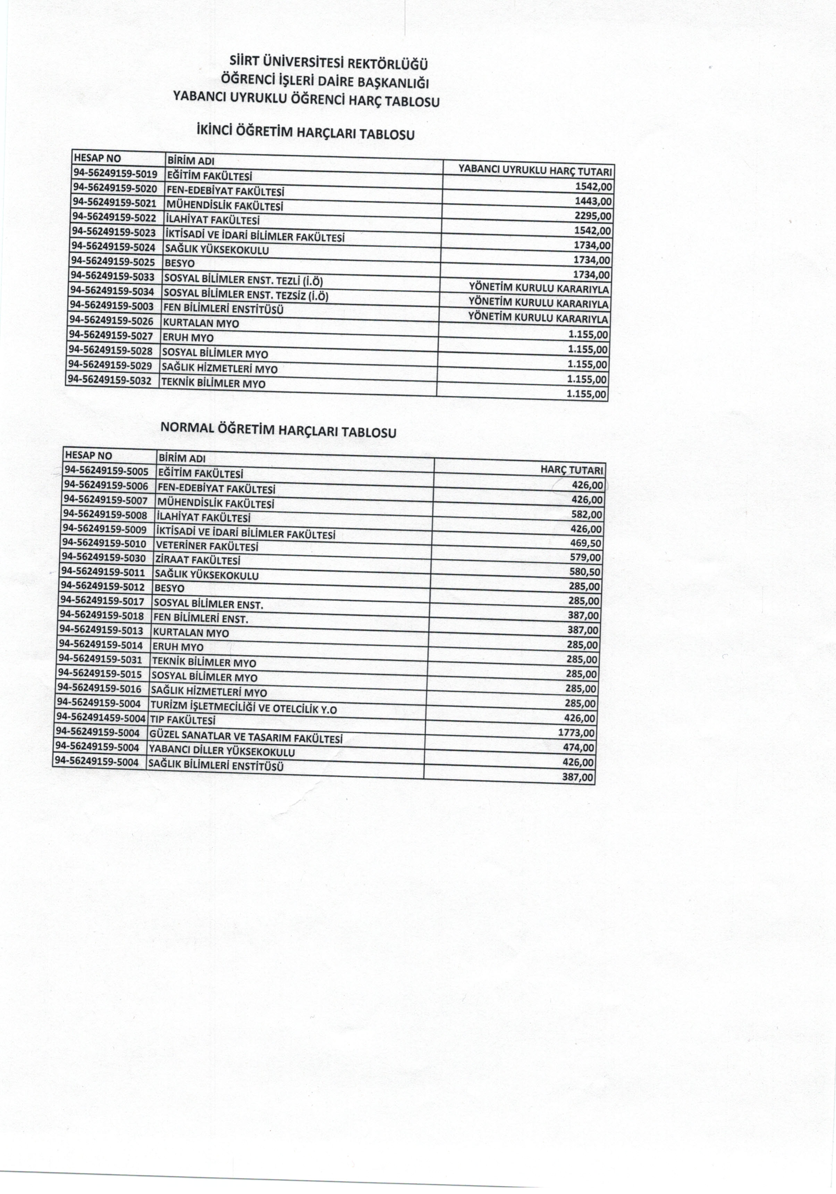

**SIIRT UNIVERSITY**

**2019-2020 ACADEMIC YEAR UNDER GRADUATE DEGREE PROGRAMMES**

|  |  |  |  |
| --- | --- | --- | --- |
| **Programın Adı** | **Name of Programme** | **Süre Duration** | **Öğretim Dili Education Language** |
| **Eğitim Fakültesi** | **Faculty of Education** |  |  |
| Fen Bilgisi Öğretmenliği | Teacher Training in Sciences | 4 | Türkçe-Turkish |
| İlköğretim Matematik Öğretmenliği | Teacher Training in Mathematics at Secondary School Level | 4 | Türkçe-Turkish |
| Sınıf Öğretmenliği | Teacher Training at Primary School Level | 4 | Türkçe-Turkish |
| Sosyal Bilgiler Öğretmenliği | Teacher Training in SocialStudies | 4 | Türkçe-Turkish |
| Türkçe Öğretmenliği | Teacher Training in Turkish | 4 | Türkçe-Turkish |
| **Fen-Edebiyat Fakültesi** | **Faculty of SciencesandArts** |  |  |
| Coğrafya | Geography | 4 | Türkçe-Turkish |
| Sosyoloji | Sociology | 4 | Türkçe-Turkish |
| Tarih | History | 4 | Türkçe-Turkish |
| Tarih (İÖ) | History (EP) | 4 | Türkçe-Turkish |
| Türk Dili ve Edebiyatı | Turkish Language andLiteraturee | 4 | Türkçe-Turkish |
| **İktisadi ve İdari Bilimler Fakültesi** | **Faculty of EconomicsandAdministrativeSciences** |  |  |
| İktisat | Economics | 4 | Türkçe-Turkish |
| İktisat (İngilizce) | Economics (English) | 4 | Türkçe-Turkish |
| İşletme | Management | 4 | Türkçe-Turkish |
| Maliye | Public Finance | 4 | Türkçe-Turkish |
| **Güzel Sanatlar ve Tasarım Fakültesi** | **Faculty of Fine Arts and Design** |  |  |
| Mimarlık | Architecture | 4 | Türkçe-Turkish |
| **İlahiyat Fakültesi** | **Faculty of Theology** |  |  |
| İlahiyat | Theology | 4 | Türkçe-Turkish  Arapça-Arabic |
| İlahiyat (İÖ) | Theology (EP) | 4 | Türkçe-Turkish  Arapça-Arabic |
| **Mühendislik-Mimarlık Fakültesi** | **Faculty of Engineeringand Architecture** |  |  |
| Bilgisayar Mühendisliği | ComputerEngineering | 4 | Türkçe-Turkish |
| Elektrik-Elektronik Mühendisliği | Electrical& Electronic Engineering | 4 | Türkçe-Turkish |
| Gıda Mühendisliği | FoodEngineering | 4 | Türkçe-Turkish |
| Makine Mühendisliği | MechanicalEngineering | 4 | Türkçe-Turkish |
| İnşaat Mühendisliği | Construction Engineering | 4 | Türkçe-Turkish |
| **Veteriner Fakültesi** | Faculty of VeterinarySciences |  |  |
| Veterinerlik | Veterinary | 4 | Türkçe-Turkish |
| **Ziraat Fakültesi** | **Faculty of Agriculture** |  |  |
| Bahçe Bitkileri | Horticulture | 4 | Türkçe-Turkish |
| Bitki Koruma | PlantProtection | 4 | Türkçe-Turkish |
| Biyosistem Mühendisliği | BiosystemEngineering | 4 | Türkçe-Turkish |
| Tarım Ekonımisi | AgriculturalEconomy | 4 | Türkçe-Turkish |
| Tarım Biyoteknoloji | AgriculturalBio-tecnology | 4 | Türkçe-Turkish |
| Tarla Bitkileri | FieldCrops | 4 | Türkçe-Turkish |
| Peyzaj Mimarlığı | Landscape Architecture | 4 | Türkçe-Turkish |
| **Sağlık Yüksekokulu** | **School of Health** |  |  |
| Hemşirelik | Nursing | 4 | Türkçe-Turkish |
| Hemşirelik (İÖ) | Nursing (EP) | 4 | Türkçe-Turkish |
| İş Sağlığı ve Güvenliği | WorkHealthandSafety | 4 | Türkçe-Turkish |
| **Yabancı Diller Yüksekokulu** | **School of ForeignLanguages** |  |  |
| Mütercim-Tercümanlık (İngilizce) | TranslationandInterpretation (English) | 4 | Türkçe-Turkish  İngilizce-English |
| **Beden Eğitimi ve Spor Yüksekokulu** | **School of PhysicalEducationand Sports** |  |  |
| Antrenörlük Eğitimi | CoachingEducaiton | 4 | Türkçe-Turkish |
| Beden Eğitimi ve Spor Öğretmenliği | Teacher Training in PhysicalEducationandSports | 4 | Türkçe-Turkish |
| Spor Yöneticiliği | Sports Management | 4 | Türkçe-Turkish |
| Spor Yöneticiliği (İ.Ö) | Sports Management(EP) | 4 | Türkçe-Turkish |

**SIIRT UNIVERSITY**

**2019-2020 ACADEMIC YEAR ASSOCIATE DEGREE PROGRAMMES**

|  |  |  |  |
| --- | --- | --- | --- |
| **Programın Adı** | **Name of Programme** | **Süre Duration** | **Öğretim Dili**  **Education Language** |
| **Sağlık Hizmetleri Meslek Yüksekokulu** | **Vocational School of Health Services** |  |  |
| Fizyoterapi | Physiotherapy | 2 | Türkçe-Turkish |
| İlk ve Acil Yardım | First AidandEmergency | 2 | Türkçe-Turkish |
| İlk ve Acil Yardım (İÖ) | First AidandEmergency (EP) | 2 | Türkçe-Turkish |
| Tıbbi Dokümantasyon ve Sekreterlik | MedicalDocumentationandSecretarial | 2 | Türkçe-Turkish |
| Tıbbi Dokümantasyon ve Sekreterlik (İÖ) | MedicalDocumentationandSecretarial (EP) | 2 | Türkçe-Turkish |
| Tıbbi Görüntüleme Teknikleri | MedicalImagingTechniques | 2 | Türkçe-Turkish |
| Tıbbi Görüntüleme Teknikleri (İÖ) | MedicalImagingTechniques (EP) | 2 | Türkçe-Turkish |
| Tıbbi Laboratuvar Teknikleri | MedicalLaboratoryTechniques | 2 | Türkçe-Turkish |
| Tıbbi Laboratuvar Teknikleri (İÖ) | MedicalLaboratoryTechniques (EP) | 2 | Türkçe-Turkish |
| **Sosyal Bilimler Meslek Yüksekokulu** | **Vocational School of SocialSciences** |  |  |
| Aşçılık | Culinary | 2 | Türkçe-Turkish |
| Büro Yönetimi ve Yönetici Asistanlığı | Office Management andExecutiveAssistant | 2 | Türkçe-Turkish |
| Büro Yönetimi ve Yönetici Asistanlığı (İÖ) | Office Management andExecutiveAssistant (EP) | 2 | Türkçe-Turkish |
| Çağrı Merkezi Hizmetleri | Call Center Services | 2 | Türkçe-Turkish |
| Çocuk Gelişimi | Child Development | 2 | Türkçe-Turkish |
| Çocuk Gelişimi (İÖ) | Child Development (EP) | 2 | Türkçe-Turkish |
| Geleneksel El Sanatları | TraditionalCrafts | 2 | Türkçe-Turkish |
| İşletme Yönetimi | Business Administration | 2 | Türkçe-Turkish |
| Muhasebe ve Vergi Uygulamaları | Accounting andTax Applications | 2 | Türkçe-Turkish |
| Sosyal Hizmetler | Social Services | 2 | Türkçe-Turkish |
| Sosyal Hizmetler (İÖ) | Social Services (EP) | 2 | Türkçe-Turkish |
| Uygulamalı İngilizce ve Çevirmenlik (İngilizce) | Applied English andTranslation (English) | 2 | Türkçe-Turkish  İngilizce-English |
| Uygulamalı İngilizce ve Çevirmenlik (İngilizce) (İÖ) | Applied English andTranslation (English) (EP) | 2 | Türkçe-Turkish  İngilizce-English |
| Yerel Yönetimler | LocalAdministrations | 2 | Türkçe-Turkish |
| **Teknik Bilimler Meslek Yüksekokulu** | **Technical SciencesVocational School** |  |  |
| Bilgisayar Programcılığı | Computer Programming | 2 | Türkçe-Turkish |
| Elektrik | Electricity | 2 | Türkçe-Turkish |
| Gıda Teknolojisi | FoodTechnology | 2 | Türkçe-Turkish |
| İnşaat Teknolojisi | Construction Technology | 2 | Türkçe-Turkish |
| İnşaat Teknolojisi (İÖ) | Construction Technology (EP) | 2 | Türkçe-Turkish |
| Kimya Teknolojisi | ChemicalTechnology | 2 | Türkçe-Turkish |
| Makine | Machinery | 2 | Türkçe-Turkish |
| Özel Güvenlik ve Koruma | Private Security andProtection | 2 | Türkçe-Turkish |
| **Eruh Meslek Yüksekokulu** | **Eruh Vocational School** |  |  |
| Çocuk Gelişimi | Child Development | 2 | Türkçe-Turkish |
| Sosyal Hizmetler | Social Services | 2 | Türkçe-Turkish |
| **Kurtalan Meslek Yüksekokulu** | **Kurtalan Vocational School** |  |  |
| Bankacılık ve Sigortacılık | BankingandInsurance | 2 | Türkçe-Turkish |
| Dış Ticaret | ForeignTrade | 2 | Türkçe-Turkish |
| Maliye | Public Finance | 2 | Türkçe-Turkish |
| Posta Hizmetleri | Post Services | 2 | Türkçe-Turkish |
| Sosyal Hizmetler | Social Services | 2 | Türkçe-Turkish |